**Q4. Use Wireshark to capture DHCP Discover, Offer, Request, and Acknowledge messages and explain the process.**

**Using ipconfig /release:**

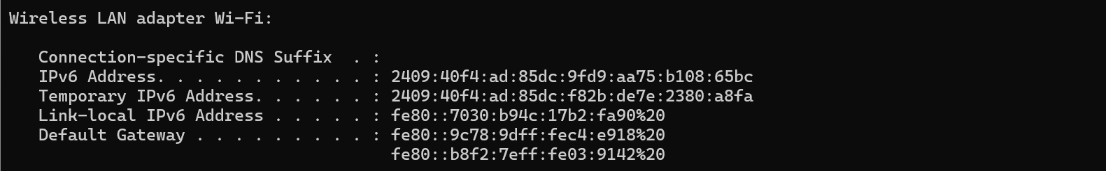

**Using ipconfig /renew:**

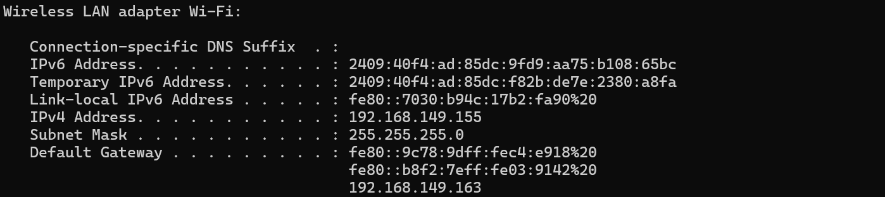

**Capturing DHCP packets using wireshark:**

